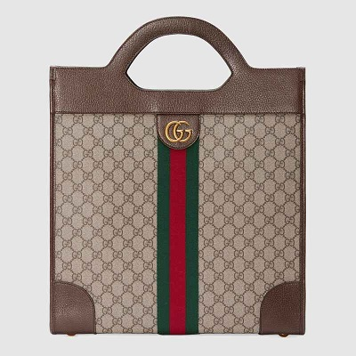

Ophidia GG medium top handle

tote

PRODUCT DETAILS

**The structured tote has become a mainstay of Gucci's collections. Introduced to the world**

**of Ophidia, the top handle bag is crafted in GG Supreme canvas trimmed with textured**

**leather and an inlaid green and red Web. A contemporary take on a Gucci archival belt**

**buckle from the '70s, the Double G is repurposed and appears atop a tab detail.**

**Green and red Web • Antique gold-toned hardware • Ophidia**